**ISMG 4750 Business Intelligence and Financial Modelling- Assignment**

**Prathamesh_Dhapodkar_109171717**

In this Assignment we are trying to forecast the revenues of eight products for upcoming three years. Variables used for forecasting are prices given for each product, raw sales data provided, total revenue.

**Revenue = Quantity*Price**

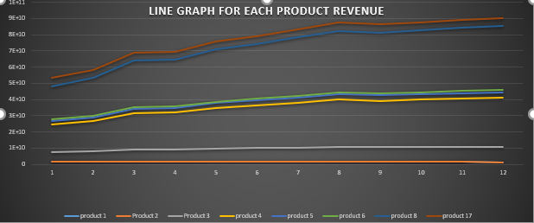

Above graph shows the total revenue of 2018 for each product. We can observe that product 8 gives the highest annual revenue.

By looking at the graph we can conclude that, Product 8 is the highest revenue generating product by considering the three year forecast. I calculated monthly forecast for year 2019 using linear regression model of forecasting, where I generated y-intercept and slope. It also generates standard error which is the distance from linear distribution to the actual value.

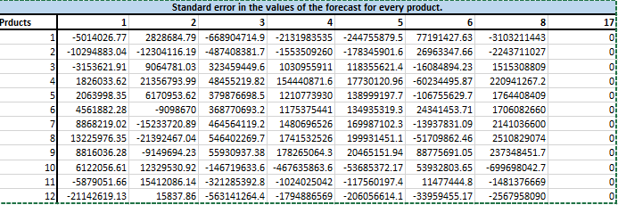



The above table shows the standard error for year 2019 forecasted value. It also requires p-value to determine the significance of the correlation of the forecasted value with the 2018 revenue table. If P-value is grater or equal to 0.05, then the generated data makes the significant changes in the distribution and we have to consider the null hypothesis.

Linear regression generates a straight line of data, because, for every y-intercept there is a slope that is generated. For the current business model “null hypothesis” considered is, the generated data is highly related to upcoming data.

The above graph, shows the trend and forecast for total revenue for year 2020 -2021.

For future prediction, I considered “weighted moving averages model” to predict the total revenue for year 2020 and 2021. Where recent data was weighted 70% and 20% and 10% respectively.

Considering the forecast and the environment of the company we can observe in the first graph that product which have one time payment is going to decrease the revenue for the company and few products with high costs perform well in revenue generation. So to maintain the equilibrium and generate profit out of low cost services the company could increase one time costs for services and introduce more services with initial benefits like we have in product 3,4,5.